Asiqul Hoque

Lab 1/Part3

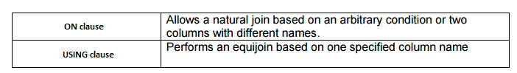

1. select department_name, location_id

from locations join departments

using (location_id)

where location_id = 1400;



2.SELECT title,comments,song_id, t.cd_number

FROM d_play_list_items c JOIN d_track_listings e

USING (song_id)

JOIN d_cds t

ON (e.cd_number = t.cd_number);

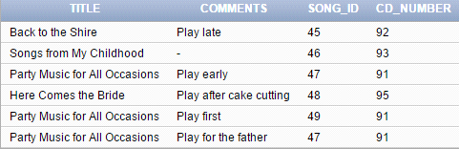

3.Select city, department_name, location_ID, department_ID

from departments d join locations l

using(location_id)

where department_id in (10, 20, 30)

and city='Seattle';



4.Select c.country_name, c.region_id, r.region_name

from countries c join regions r

on (c.region_id=r.region_id)

where r.region_name='Americas';

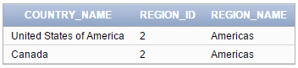

5.Select e.last_name, e.hire_date, e.job_id, j.job_title, j.max_salary

from employees e join jobs j

on (e.job_id=j.job_id)

where max_salary>12000;

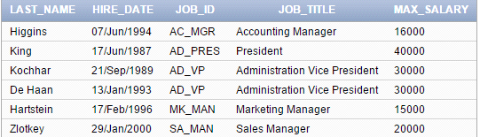

6.Select j.job_title, e.first_name, e.last_name, e.email

from jobs j join employees e

on(e.job_id=j.job_id)

where job_title='Stock Clerk';

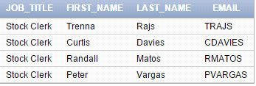

7.Select e.employee_id, e.first_name, e.last_name, e.manager_id, m.first_name, m.last_name

from employees e join employees m

on(e.manager_id=m.manager_id);

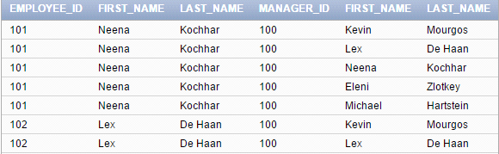

8. Select l.location_id, l.city, d.department_name, country_id

from locations l join departments d

on (l.location_id=d.location_id)

where country_id = 'CA';



9.Select e.manager_id, d.department_name, d.department_ID, e.first_name, e.last_name

from departments d join employees e

on(e.department_id=d.department_id)

where e.department_id in (80, 90, 110, 190);

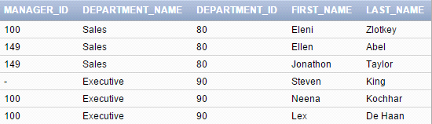

10.Select e.employee_id, e.last_name, d.department_id, d.department_name, e.hire_date

from employees e join departments d

on(e.department_id=d.department_id)

where e.hire_date='07-jun-1994';

